Pir Sultan Abdal
(1547 – 1590)
reflects the social, cultural and religious life of Alevism.
He was a humanist and wrote poems about resistance, love, peace and God. The picture is important for Alevis because it also represents saz which Alevi refer to as the ‘holy book with strings’.

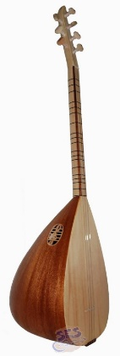
Baglama/Saz,
is used in worship/Cem ceremonies.
Also known as the
“holy book with strings”

Holly Stone (Teslim Taşı)
Represents Hunkar Bektas-I Veli
and 12 Imams
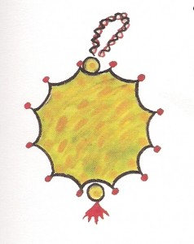

Lokma (AŞURE ) (sacred meal in Alevism).

The Zulfikar/ Sword,
represents St. Ali, justice and peace.

