I can identify key roles of the 12 volunteers who take part in the Cem ceremony

Service | 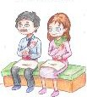  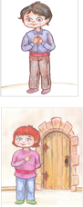  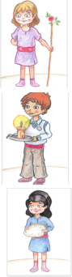 | What they do and how it helps the Cem ceremony
Pir
(Dede / Ana)
Guide
(Rehber)
Door keeper
(Kapici)
Cem Keeper
(Gozcu)
Candle lighter
(Cerag)
Fleece Keeper
(Postcu)

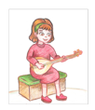
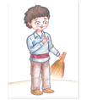
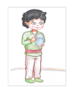
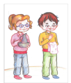
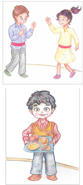
Musician
(zakir)
Sweeper
(supurgeci)
Water server
(sakkaci)
Jug server
(Ibrikci)
Semah performers
Food server
(lokmaci)

