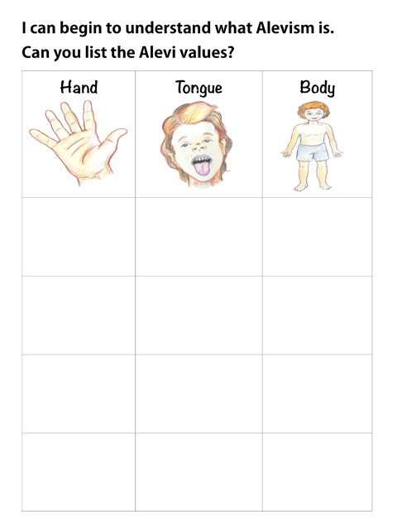Pupils write and/or draw in boxes two examples of good and two bad uses of hand, mouth/tongue and body

