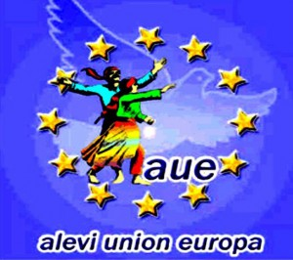

ALEVI UNION EUROPE

18 March 2015
EUROPEAN PARLIAMENT
BRUSSELS/BELGIUM
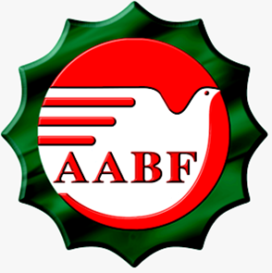

FEDERATION OF GERMANY ALEVI UNION

18 March 2015
EUROPEAN PARLIAMENT
BRUSSELS/BELGIUM
Federation Of Germany Alevi Union

The successes and achievements in the past 25 years

The Federation of Germany Alevi Union was formed in 1989 by German Alevis uniting and saying “only Alevis can save themselves“.

There are many reasons behind Alevis becoming organisational in Germany. However there are 3 main ones that stand out amongst these reasons;

- The Alevi immigrants moving in to Germany have moved from being guest workers to settled members of the German society, thus making them important contributors both in Germany and in rest of the Europe,
- To live with their belief and religion in Germany and keep it alive. And the desire to teach the future generations of their religion and stop them becoming assimilated by the majority population,
- In order to support the Alevi struggle in Turkey. To stop the Alevi assimilation in Turkey. The government violence and the pressure against the Alevis to be stopped in Turkey.

As as result of the rightful and honourable struggle in the past 25 years, AABF has achieved a lot. These achivements and successes are resulting in important milestone to be achieved by the Alevis Worldwide.
Achievements

To unite Alevis under an organisation:
- Under the roof AABF there are 148 Alevi Cultural Centres and cemevis not just in in cities, but also in towns and villages.

Acceptance of Alevism:
Alevism has been accepted as a unique religion in Germany. In connection to this AABF has the sole right to represent the 800 thousand Alevis living in Germany.

To purchase the Cemevi buildings and acceptance of these places as places of worship:
- Under the AABF roof, about 90 AKM’s own their own buildings, this indicates that the Alevis are here permanently. The Cemevi buildings are recognised as places of worship in Germany.
.
Recognition of Alevi Ana/Dedes as religious leaders:
- Germany has recognised the anas and dedes as the religious leaders. In line with this, they are able to travel to Germany without needing visitor visas.
Alevism Lessons:
- Alevis recognised as a religious group in Germany, with the German constitution‘s rule number 87 and 3rd part, have been able to receive Alevism lessons at German State schools since 2002.
- AABF was given the right to the preparation of the Alevism lesson curriculum and to attain the educators to teach these lessons,
- The Alevism lesson exam results are included in the calculation of the final achievement grade as similar to any other subject studied.

Furthermore, as a result of the different education system adapted in different states, at the State of Hamburg, all religions are taught under the lesson of “Dialog between different religions“. Alevism has been included in the 2015-2016 Academic year’s curriculum booklet of “Dialog between different religions“ at State of Hamburg. All students in primary education in Hamburg State are taught Alevism in the same way as they have been learning about Christianity, Jewism and Islam.

Acceptance of Agreements for Equal Rights:

- State of Hamburg, public equality aggreement has been signed with the State leader Mr Olaf Scholtz on 13th November 2012,
- State of Lower Saxony (Niedersachsen), public equality aggrement has been signed with the state leader Mr Stefan Weilile on 30th September 2013,
- Bremen public equality aggrement has been signed with the State leader Mr Jens Bohrsen on 14th October 2014,
- The aggrements signed means, Alevis have the same rights as the Christians, Jews and Muslims in these areas. This means that the Alevi rights and demands have been placed under the government guarantee.

Starting the Alevi stands in Universities:

- On 16th April 2014 at the BW Weingarten Education Faculty the “Alevi Pedegogy Major Section“ has been opened. The teachers graduating from this school will have the right be able to teach Alevism lessons at the German State schools in every state,
- On 30th January 2015 at the University of Hamburg, the World Religion Faculty, “The Alevism Major Section“ has been opened. This also carries the status of being the first and only Alevi stand,
- This means Alevis are able to write their own history at their own universities. They are going to be saved from the dirty history and the terminology. Alevis with this important achievement are going to be able to fight against the assimilation in a more determined manner, with the researches carried out to conribute to the study of Alevism.

AABF being elected to the State of North Ren Vestfalya (NRW) Press Commission:

- On January 2015 at the State of North Ren Vestfalya Parliament, AABF has been elected to the KRV Press Commission with the majority vote.
- For the first time an organisation representing the ethnic minorities have been selected for this commission (RTUK).

AABF’s RELATIONSHIPS FORMED AND POSITION
With the invitiation of the German president Joachim Gauck:

- On 10th January 2012 New Year Reception, on 30th August 2013 President’s Community Festival, on 22nd May 2014 the 65th anniversary of the German Constitution and on 21st January 2015 again with the invitation of the president we have attended the events taking place at the Schloss Bellevue Castle,
- On 21st March 2014, the President Joachim Gauck has visited the Berlin Cemevi for the Newroz celebrations,
- The top of the leadership protocol in Germany the German Presidency’s being in contact with Alevis, clearly indicates the way they perceive AABF.

The relationship with the German and Turkish political parties:

- SDP leader Mr Sigmar Gabriel has given a speech at the AABF‘ Annual general meeting held in 2013,
- The German Left wing party leader Mr Bernd Riexinger and one of The Green Party’s leading members Mr Volker Beck has visited our headoffice,
- One of the CDU’s leading members Mr Volker Kauder, has invited AABF to Berlin,
- AABF headoffice was visited by the CHP Leader Mr Kemal Kılıctaroglu and HDP joint leader Mr Selahattin Demirtas,
- In parallel to all of these connections, ongoing relationships exist with other religious grups, organisations and charities and various events are carried out jointly.

Having right to speak on every issue about humans in Germany:

- AABF has formed the Belief Commission, Unity of German Youth (AAGB) and Unity of German Alevi Women in 1994, in order to meet needs of all different groups,
- Afterwards; with the establishment of AABF Culture and Art Commission, Science and Research Commission, Unity of European Alevi Academics, Legal Commission, Union Commission, Funeral Collective, it has been aimed to meet the needs of all aspects of life and all the population,
- AABF has taken an important role in setting up the Platform of United German Democracy. This way, it has received the identity of an organisation of social peace, tranquility and unity, in order to serve every aspect of life.
- AABF’s mission and vision is as well as being a religious organistion, also to receive the identity of being a civil society organisation.

AABF and the projects undertaken;

- New County Project:(Meine Neue Heimat) finanziert durch den Europäischen Integrationsfond (EIF) and Bundesamt für Migration und Flüchtlinge (BAMF)
- this project aims to; to enable the people moving from Turkey to Germany to receive the education seminars in order to enable them to find out about all aspects of life such as social, political, cultural, economical aspects.
- With the seminars in Turkey, to educate the individual planning to move to Germany from Turkey, in German social, political, cultural, economical life.
- The Management Training Project: Profem (Qualifizierung ehrenamtlicher Vorstandsmitglieder) finanziert durch Europäischer Integrationsfond (EIF) and Bundesamt für Migration und Flüchtlinge (BAMF)
- this project aims to; AKM-Cemevi management to be trained, their knowledge and skills to be maximised and enable them to improve the quality of the service they provide to their community.
- The Environment Project: (ÖkoCan und MehrUnternehmen) Umweltprojekte finanziert durch
Umweltbundesamt.
- this project aims to; to make especially the ethnic minorities more aware of their environment and nature,
- Show the way Project: (Zeichen Setzen) Initiative Demokratie Stärken- Toleranz
Fördern-Kompetenzen Stärken Das Bundesamt für Familie and zivilgesellschaftliche Aufgaben.
- this project aims to; explain clearly the violence, racism in Germany, the main aims of the ethnic minorities and their targets. To share ans explain the whole picture by sitting around a round table,
- Strukturelle Förderung von Migrantenorganisationen in Kooperation
mit Deutscher Paritätischer Wohlfahrtsverband (DPWV e. V.)
finanziert durch BAMF. This is the support given to the management to enable them to serve their community more effectively.

Germany carries a social government identity. The social services provided are therefore very important. The Alevi organisations serving in Germany have taken the weight off the government’s shoulders by providing many of these social services. The projects we have listed above contributes considerably to the community peace, love, understanding and integration.

Alevis have received their freedom in Germany and we demand their freedom in Turkey too!

Regards

Mr Huseyin Mat
AABF Chairman

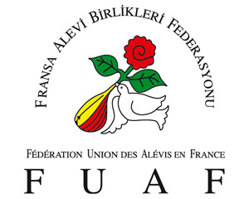

FEDERATION OF FRANCE ALEVI UNION

18 March 2015
EUROPEAN PARLIAMENT
BRUSSELS/BELGIUM

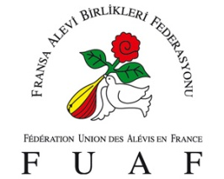
INTRODUCTION OF FUAF
Unity Of France Alevi Federation (FUAF) was formed in French city of Bar Le Duc in 1997 by contribution of 5 Alevi Cultural Centres (AKM).
The first general meeting in 1998 was in Strasbourg, 14 Alevi Cultural Centres attended this meeting.
THE FRANCE ALEVI ORGANISATION
It is estimated that, over 30 thousand Alevi’s are living in France and at least 80% of those holding French citizenship.
FUAF, has been formed to meet the belief and community needs in France, with total of 37 Alevi Cultural Centres and 20 thousand active members.
FUAF’S AIMS
- To unite all AKMs in France under one roof.
- To answer the religious, cultural, social and community needs of the Alevis living in France and to enable them to understand the French laws and their rights in France, and to aid them to live in harmony with other communities in France.
- To educate our youth and children and other French communities and explain the Alevi humanist philosophy, belief and culture.
- FUAF will introduce Alevism to our own organisations, French offical organisations, companies and charities. It will work in liaison with them and carries out joint projects. It will take Alevi problems to relevant bodies and requests aid from them.
- The senior commissions formed within the Fedaration will aim to find solutions to the Alevi needs.

The 12 Senior Commissions formed within the FUAF:
- Public Relations Commission,
- General Secretarial and Diplomacy and development Commission,
- Culture and Art Commission,
- The General Treasurer and project, resource and law Commission,
- Press and Publication Commission,
- Women. Family and Children Commission,
- Association Commission,
- Youth Commission,
- Route and Belief Commission,
- Environment and Nature Commission,
- Education and Research Commission,
- Tradesman and Businesses Commission.

FUAF's activities:
- FUAF, aims to educate Alevis in French laws and their democratic rights, to enable them to use their rights fully.
- FUAF, aims to educate the youth and children about the Alevi belief, culture via the AKMs.
- FUAF’s 3 main aims are as follows;
a) To become organisational,
b) Education,
c) Outside relations, expansion and diplomacy.
FUAF in order to bring the projects to life is working with the 12 commissions.
- FUAF, has made applications to the European Parliament and the European Court of Human Rights in Strasbourg, in order to inform them of the Alevi demands. Mr Hasan Zengin’s case of “compulsory religion lessons” have been followed closely by FUAF and contributed considerably to the positive outcome received.
- The International Women’s Day has been celebrated with attendance of European women and European Parliament members under the roof of European Parliament. We have performed our semahs at the European Parliament.
- Alevism seminars took place at the most prestigious universities such as the Paris Sorbonne and Strasbourg Universities.
- FUAF has formed an Environment and Nature Commission, in order to explain the way Alevis perceive the nature, the films showing environmental problems, organising debates and contributed to nature cleaning projects.
- The highly prestigious cultural event ; ‘ASK OLA’ took place in the capital of Europe ; Strasbourg, in order to present the way Alevis perceive the human.
- At one of the most famous halls in Paris ; Palais des Congres, Alevis and the way they perceive the nature, was explained with the aid of four elements (air, soil, water and fire). Ballet, opera, symphony orchestra, light effects, words and visual effects were used, 80 baglama players, 80 choir members, 80 Semah performers took part in the FUAF’s ’DOGA ASKINA’ event to celebrate the 15th anniversary.
- FUAF has organised a rally outside the European Parliament in Strasbourg, with attendance of 15 thousand people in order to say ‘NO to discrimination, assimilation and wars’. Semah’s were performend outside the European Parliament for peace.

- The Sivas victims were remembered with Semahs performed under the Eiffel Tower in Paris.
- FUAF was invited to the Presidential Palace (Elysee Palace)
- Regular liaising and meetings held with both the Home office and the Ministry of Foreign Affairs.
- Alevi symposium was organised by FUAF at the French Parliament for the, members of the Parliament.
- FUAF has enabled the Alevism to meet at the same table with other religious groups.
- Alevis and FUAF’s current daily agenda and their interpretation of these current affairs have been published in Le Monde Newspaper.
- News, articles and research have been published in the monthly magazine Voice of Alevis both in French and Turkish
- FUAF – Funeral Fund Social Support Organisation has been formed.
- FUAF’s Funeral Fund has organised periodical funeral procedures and education seminars according to our belief.
- FUAF Route and Belief Commission, organises Ana-Dede education seminars regularly.
- ‘Ma Source’ the organisation of French Employees has been formed in order to say it is possible to form an economic power by placing the human and the nature in the centre.
- The television programme France Reflections has been broadcasted on YOL TV regularly.
- Leaflets, magazines, brochures and other documents in order to publish Alevism has been produced in Turkish and French. FUAF Diplomacy and Development Commisions have made presentations to the French community in order to represent the Alevism.
- FUAF internet site (www.alevi-fuaf.com) is serving in Turkish, French and German.
- The main centre has been serving for 8 hours a day which has enabled us to then take an important step towards becoming organisational.

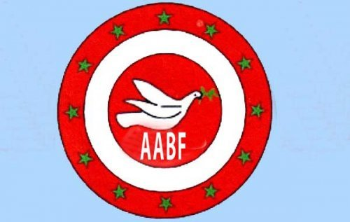

FEDERATION OF AUSTRIAN ALEVI UNION

18 March 2015
EUROPEAN PARLIAMENT
BRUSSELS/BELGIUM

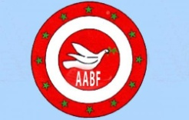

The heat is from the flame not from the iron steel;

The miracle is in the head, not in the crown.

Whatever you are searching for, search within yourself,

Not in Jerrusalem or not in Mecca. (Haci Bektas Veli)

Austrian Alevis united under one roof and said the Alevis can only be the saviour for themselves and from the United Alevi Federation of Austria in 1988;

There are many reasons behind the Alevis organising in Austria. However amongst these 3 main ones stand out.

- Alevi citizens of Austria have moved from status of guest workers and become real citizens and part of Austria, therefore becoming very important units of both Austria and Europe,
- In order to live with their belief and religion in Austria, keeping it alive and save themselves from becoming influenced by the majority culture, and avoid assimilation and to pass on their belief and religion ot the future generations,
- Alevis in Austria united together in 1989 and parallel to the other Alevi organisations in other countries have started their own organisation, in order to support the rights and struggle of Alevis in Turkey; to help the Alevis in Turkey avoid assimilation, to stop the governemnt pressure and violence against Alevis in Turkey.

Unity of Austrian Alevi Federation (AABF) have conributed considerably to the movement of Alevis in Europe in the past 25 years. These gains and achievements are important milestones for all Alevis worldwide.

These are;
1- To become organised and united under one roof;
- In Austria these are a total of 12 Alevi Cultural Centres and Cemevis, these are not just in cities but also are in towns and villages.

2- Recognition of Alevism;
- We will achieve recognition in Austria in near future, in connection to this AABF has the sole right to represent 60 thousand Alevis living in Austria.
3- To own our Cemevi buildings;
- 5 Alevi Cultural Centres own the rights of their buildings and others are also in search of moving in that direction. This proves that the Alevis are here in Austria permanently and they are in acceptance of this fact. We can see clearly now the importance of our own advice in the past of Alevis to own their own buildings. Our prediction of how important it was for us to feel settled by owning our own buildings is now confirmed.
5- Alevism lessons;
- Alevis in Austria are determined to have their religion recognised as a unique religion.
- Alevis are working together to have their religion recognised as a subject to be taught at the Austrian State schools.
- In order to achieve this, seminars will be organised to train educators at the Alevi Cultural Centres.
.6- AABF funeral service and company;
- In order to share the grief and aid our communith in times of breavement, we have set up the Austria ABF Can’s Funeral Aid and Help Fund 2009.
7- Forming AABK;
- Unity of European Alevi Federation was formed with our support and we took our part in the original set up committe.
8- Forming Turkish ABF;
- We have supported the formation of Alevi Bektasi Federation in Turkey and aided them in getting their legal recognition.
9- Voice of Alevis magazine;
- We have supported the voice of Alevis Magazine being published since 1994 both finacially and ideologically.
10- Compulsory Religion lessons;
- The compulsory religion lessons which are aginst the main human rights and freedom have also been condemned by the European Human Rights.
- The compulsory religion lessons imposed by the Turkish government are opposed mainly by the Alevis and other members of different religious groups.
- AABF, in order to oppose this; in line with one of the main reasons for their formation has supported Eropean Alevi Federation’s petition and have brought this subject to every platform we have represented Alevis.

11- Cemevis in strategic locations such as; Sivas, Erzincan, Maras and Dersim;
- We have helped in opening of Cemevis firstly in all areas where there is a density of Alevi population and all other areas.
12- To turn Madımak Hotel into a museum of shame;
- We have supported the rightful fight of victim families whose loved ones were murdered by setting alight in Madimak Hotel in Sivas. We have helped gather support for the petition in Europe and helped with all aspects of this campaign.
13- Yol Tv;
- In order for Alevis to set their own agenda and to be able to fight the current system, we have helped in formation of the Yol Tv. We can become guests in homes of millions of Alevis by help of Yol Tv.

AABF aid campaigns and helping others and sharing their pain;

We have tried to help;

- To those friends who took refuge in our Cemevis and have escaped from Syria,
- The Victims of Gezi demonstrations,
- The Earthquake in Van and helping building with TMMOB,
- To aid the family in Malatya Surgu with the legal costs of their court case,
- To Sengal Ezidis.
- To Kurdish citizens in Kobani.

2012 - 2015 years have been announced as AABF educatiuon movement years.

Education movements, in order to become organised and to touch every aspect of life and service sectors.

- Management Education Seminars
- Dede/Ana Education Seminars (Pir, Rehber, Mürşit trianglei and Pir Talip relationship) Young Dedes/Anas and Budget.

- Alevism lessons- to educate the teachers

AABF and Rallies

In Turkey; to support Maras, Corum, Sivas, Gazi massaccare rallies

In Germany; to support 2009 Cologne Dom, 17th March 2012 Bochum, 22nd June 2013 Cologne Heumarkt and 24th May 2014 Cologne Rallies.

In order to abolish the anti democratic and assimilation policies against minorities by Turkish government, we have organised global demonstrations. We have tried to inform the Austrian community and European community of this situation.

While our religion does not receive acceptance and recognition in Turkey, while our Alevi children are being assimilated by compulsory religion lessons, we have been battling in order to free Alevis in Austria and rest of the world.

Thank You.

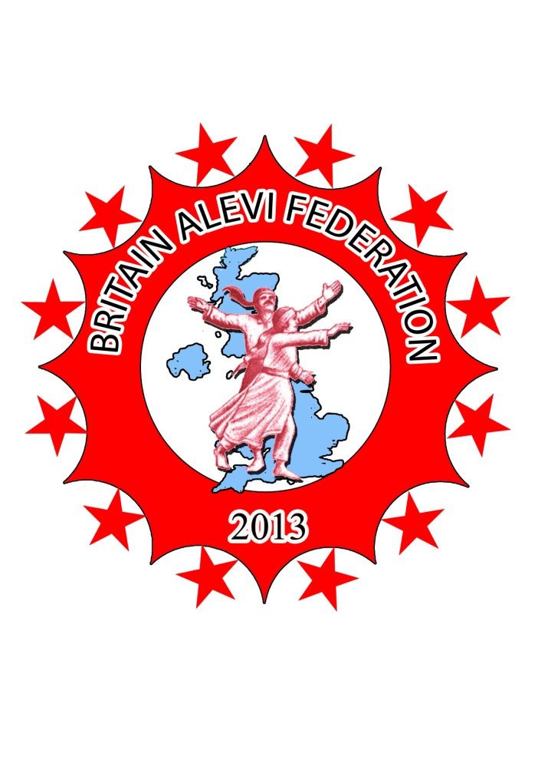
BRITAIN ALEVI FEDERATION

18 March 2015
EUROPEAN PARLIAMENT
BRUSSELS/BELGIUM
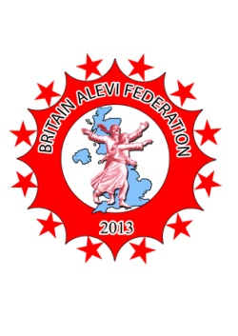Britain Alevi Federation
The Alevis who are still banned by the Turkish Constituion as a result of the pressures and massacres they faced for many years have found it imposibble to live in Turkey.
In addition to Kocgiri, Maras, Corum and many other Alevi massacres, following the military coup in 1980, the compulsory religion lessons forced upon Alevis at schools are the attempt to destroy Alevism totally.
Alevis immigrated to Britain, which is formed by unity of Scotland, Wales and Northern Ireland from mid 1980s. This compulsory immigration took place as a result of the massacres against Alevis, and the Alevism being banned in Turkey together with economical factors. The first Alevi Cultural Centre and Cemevi was founded in Dalston area of London in 1993. Following the massacres in Madimak in 1993 and Gazi in 1995 Alevis realised the importance of being organisational and mainly gathered around cemevis. Until 2008, there was only one AKM and Cemevi in Britain, today there are 12 AKM and Cemevis in Britain and Britain Alevi Federation has also been founded.
AKM’s and Cemevis are based in areas where there is Alevi population density such as ; London, Croydon, Glasgow, Edinburg, Doncaster, Nottingham, Harrow, Hull, Sheffield, Coventry, Leicester and Bournemouth. There is an immediate need also in; Edmonton, Liverpool, Suffolk, Kent, Devon, Wales and Ireland.
We carry out our cems every year, our dedes come from Turkey and other European countries to lead our cems.
All Alevi cans have their funeral services carried out at our AKM and Cemevis.
The celebration of our important anniversaries, massacres remembrance services and asure and fasting events also take place at the Cemevis.
We take part in all festivals, rallies, panels, meetings and memorials in Europe and in Turkey,
In July 2014, we have taken action to free the Haci Bektas Veli Dergah from the government occupation . Our action was suitable both to our religion and to our dergah, in the form of carrying out a cem ceremony. As with the example of the Macedonian Harabati Dergah based in the middle of Europe, all our dergahs are occupied by the Islamic Sunni understanding. For this reason, despite the embargos, the Cem ceremony that has taken place at Hace Bektas Dergah is our honour.
We always take part in every right and justice protest that take place in Britain.
As in the case of the victims of the KTHY passengers, we have taken their side in order to aid them gaining their refunds.
National Education Curriculum Committee has agreed to have Alevism taught at primary and secondary schools in Britain. This curriculum is being implemeneted in some areas in Britain for the past three years. We are going to continue with our work to increase the numbers schools anf make this a widesread situation. The fact that all students are learning about Alevism is an important step towards expaining our culture and values to all other communities living in Britain.
Qızılbas publications have been founded. The publishing company has published three very important books aimed at children. CEM, SEMAH and KAYGUSUZ ABDAL books explain important subjects both in Turkish and English, they are being accepted as very important contributions to the Alevi world.
Britain Alevi Youth Federation has been founded. BAGF is carrying out important and promising work for the future of our youth.
Our youth struggle with their identity as a result of the immigrant lives and being stuck between two different cultures. For this reason we are carrying “who are we” titled youth activities.
We are organising the Britain Alevi Festival in London every year with thousands of people taking part.
Unity of Britain Alevi Women has been founded. BAKB organises out events, meeting, seminars and demonstrations in order for Alevi wormen and all other women to gain equality and freedom for women in order to achieve their positions they deserve to be in.
Britain Alevi Federation Funeral Services has been founded. Our people alieve and dead are still important for us. We want send them away to their final journey in the appopriate way.
Britain Alevism Research Group has been founded. The groups are carrying out important academic work in order to shed light to history and to guide us to our future.
We are also trying to enlighten the events surrounding the Dersim massacre. With this aim, we have organised the showing of HAY WAY ZAMAN documentary film shown at the British Parliament. the Showing was attended by many academics and politicians. We want to organise a showing in the European Parliament in the future.
We have made requests to the Turkish government to handover the Maras Archieves to us in order to have the Maras massacre to come out to the open. We have received reply from them to say the archieves being in the military’s possession and not allowed to be handed out to anyone. We go to Maras every year to remember the massacre.
We take part in the rememberence events of Sivas, Corum and Gazi massacres. There is a rememberence statue in London for those who lost their lives in Sivas.
We supported the Taksim Gezi Park Protests in 2013. We have planted trees in London in the name of those who lost their lives during the Gezi events .
We are having meeting with British and Turkish prime ministers, ministers, burocrats, MPs and local government leaders, all politicians and parliament members who we can reach , in order to inform them of the Alevis and human right demands.
We condemn the violance that is taking place in the Middle East and ISIS savagery in every platform. We are fighting for the freedom of all Alevi, Kurd, Ezidis Christian, Arab, Turkoman, Armenian and all women in the area.
BAF’s main aims and activities:
- BAF, works towards allowing Alevis living in Britain to live in Alevi ways and in order to pass it on to the future generations.
- BAF, organises activities in order to explain Alevism all other communities.
- BAF, works towards having the Alevi youth and all other youth to receive education in a healthy, modern, secular and democratic world.
- BAF, fights to receive equality and freedom for Alevi women and all other women.
- BAF, support all work in order to free all discriminated beliefs, identities and nations.
- BAF, supports the rights and struggles of the working sector.
- BAF, works towards having Alevism taught at British primary and secondary schools.
- BAF, fights to have all Alevi massacres to be in the open and to have those responsible to face the consequences of their actions.
- BAF, works to politically represent Alevis in Britain and other countries.
- BAF, works in order to have Alevism taught at universities.
- BAF, fights against energy production projects such as HES, RES, GES that destroy the nature based on its God, Nature and Human understanding.
- BAF, fights to gain control of the places like Dergahs, Tekkes and Zaviyes that actually belong to Alevis but have been occupied by the Ottomans and the Republic of Turkey.
- BAF, is in liasion with mainly with immigrant Alevis and all other immigrant groups that have immigrated to Britain, it fights against assimilation and support integration.
Britain Alevi Federation

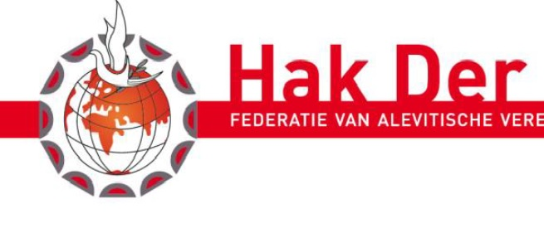
UNITY OF HOLLAND ALEVI FEDERATION

18 March 2015
EUROPEAN PARLIAMENT
BRUSSELS/BELGIUM

Unity of Holland Alevi Federation
The Successes and Achievements in the past 25 Years
Establishment:
- 10 Alevi-Bektasi Cultural centres in Holland’s cities of; Rotterdam, Deventer, Amersfoort, Haarlem,Hilversum, Oss, Zaandam, Alkmaar, Amsterdam and Maastricht; has united in order to be able to raise their voices and to be able to solve problems more effectively and Holland Alevi-Bektasi Social and Cultural Centres Federarion (HAKDER) was founded in 1990.
- The organisational route and the principals were drawn by the acceptance of “General View and principles Report” at the annual general meeting held in 1996.
- The name has been changed to Unity of Holland Alevi Federation at the constitution meeting help on 10th January 2015, the shortened name remained as HAKDER. At this meeting, especially the principle of “Alevism is a unique and independent belief” has been included in the constitution, and it is aimed to stop the Turkish government’s and its other organisation’s attempts to influence Alevism to make it more Islamic and assimilated belief.

Reasons for establishment:
- In order to have an active and stronger positions in every aspect of life in Holland as Alevis.
- In order to research the Alevi belief, Culture, lifestyle, ideas and philosophical treasures, historical and cultural wealth; present and protect it.
- To aid Alevi individuals in integration into communities they live in and bring them to the levels they deserve to be in.
Our Vision and mission:
- Our Vision: to follow all recent developments and find effective and intelligent answers in order to present Alevism and aid it becoming organisational, to create an Alevism reality that is reputable and is in line with the global expectations and to keep the Alevism on the agenda.
- Our Mission: Alevi identity and democratic legal rights to be recognised in Turkey and all over the world, to make contributions in order to allow Alevis to live freely and with all other communities under their own Alevi identity.
Principles and Ideas:
- Hak-Der; believes Alevism is an Unique and independent belief and does not accept our belief to be part of any other belief or to be under the same roof with another religion.
- Hakder; is a democratic mass organisation. It works inline with Holland’s legal system. It has not got any connection with any political party, organisation and company. It only has connection to the organisation above itself; Unity of European Alevi Confederation (AABK)
- Hak-Der; aims for all the native community and immigrant communities in Holland to have equal rights, it fights for the peace and friendship of all communities.
- Hak-Der; respects global principles of Law, human rights and freedoms. It defends all these principles under any condition.
- Hak-Der; enable Alevis to integrate while protecting their own belief, culture and identities; aims to meet the demands in the social and cultural areas.
- Hak-Der; the aims and principles will be either establishment on its own or with aid of other member centres.
- Hak-Der; carries out activities in order for the Holland Alevis to protect and develop their cultural self, belief and philosophical values.
- Hak-Der; works in order to have the Alevi youth to be raised secular, democratic and modern way, inline with their culture, belief and doctrine.
- Hak-Der; carries out and organises scientific research to be carried out, in order to keep the Alevi culture alive, permanent and global.
- Hak-Der; organises all events to remember ozans, dedes and all similar persons, who are the carriers of the Alevi culture and doctrine.
- Hak-Der; aims to abolish prejudices and achieve respect and love between different religious beliefs and sects.

Some examples of the up-to-date events:
- Stood against the discriminative and offending statements of Rector of Rotterdam Islamic University A. Akgunduz,
- The “Management and staff Booklet” for the organisation management Committees have been published by HAKDER,
- Alevism introduction booklet has been published in Dutch,
- The representatives of the government, the deputy prime minister, social matters minister Asscher has visited our organisation,
- Joint work has been carried out with other democratic organisations,
- The projects for “Homosexuality” and “violence against women” has been carried out,
- Projects for Antisemitism has been undertaken.

Relationships:
Hak-Der is one of the establishing members of the Unity of European Alevi Confederation.

Hak-Der in Holland is a member of; IOT (the organisation for information for Turkish people), and gives advise to the Holland government on behalf of the Alevi community.
Hak-Der is member of Humanistische Aliantie (Unity of Humanists) in Holland. All the organisations that defend the humanism philosophy in Holland are members of this organisation.
Hak-Der, has been formed in order to find solutions to religious, social, cultural, educational, economic and political problems if the Alevi population, tries to establish the coordination of its member organisations, and carries out events in order to meet these needs. Prepares projects in these subjects and works in liason with relevant organisations.
Becoming organisational:
According to Prof. Koningsveld from Leiden University, there are nearly 100.000 Alevis living in Holland.

According to our new constitution, only member organisations can join our federation. Hak-Der, today with its member organisations has 2000 active members.
Has a right to speak regarding any issue about the Alevis in Holland. It does not receive any support from any external power, government, Republic of Turkey organisation in any way.

Our demands from Turkey:
- The “compulsory religion lessons" that are taught at schools and places the Alevi children under the Islam umbrella must be abolished;
- The Ministry of Religious Affairs, that should not exist in a secular country must be abolished.
- The building of mosques in Alevi villages must stop and imams at Alevi villages must be called back;
- The names like “Dede and Baba” that are used to describe the Alevi leaders must be taken out of the list of banned words;
- The RELIGION section in the birth certificates must be removed;
- The Alevi’ Sercesme; Hunkar Haci Bektas Veli Dergah and all other Alevi Dergahs must be handed back to Alevis;
- Madimak must be turned into a museum.
- The fact that the Alevism is an Unique and an independent religion must be accepted legally.
- Our Cemevi must receive the status of “Religious place”.
Our demands from Holland:
- Alevism lessons to be taught at Holland schools and to have a place in the “community subjects”,
- To take extra care of Alevi children and youth, at the times of “Islamic holly days”, in order to avoid any discrimination and pressure on them,
- The local government organisations to aid the Alevi organisations in obtaining rights to use buildings in order practice their religion,
- The Ministry of Education to set the required budgets in order to enable the scientific research in to Alevism,
- To take action against any type of discrimination against the Alevis and Alevi belief by Islamic and Muslim organisations,
- HAKDER who is the leading representative for the Alevi community to receive the same attention and approach shown to other Islamic and religious groups,
- Not allocating “Hocas” to Alevi cans at military, prisons, hospitals and enable the basis to be formed, and ask HAKDER to refer “Dedes” in order to meet their religious demands.

18th March 2015, Brussels

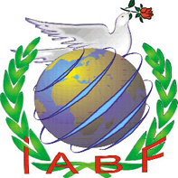

FEDERATION OF SWITZERLAND ALEVI UNION

18 March 2015
EUROPEAN PARLIAMENT
BRUSSELS/BELGIUM

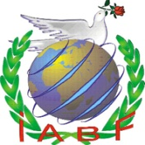 Unity of Switzerland Alevi Federation
Achievements and Successes in the past 20 years

Alevis in Switzerland who said “My Kaaba is the human“ has joined together to form the Unity of Switzerland Alevi Federation in 1998.

There are many reasons for the Swiss Alevis to be organised. However three main ones stand out amongst these;

- Alevi citizens of Switzerland have moved from status of guest workers and become real citizens and part Switzerland, therefore becoming very important units of both Switzerland and Europe,
- In order to live with their belief and religion in Switzerland, keeping it alive and save themselves from becoming influenced by the majority culture, and avoid assimilation and to pass on their belief and religion ot the future generations,
- Alevis in Switzerland united together in 1998 and parallel to the other Alevi organisations in other countries have started their own organisation, in order to support the rights and struggle of Alevis in Turkey; to help the Alevis in Turkey avoid assimilation, to stop the government pressure and violence against Alevis in Turkey.

Unity of Switzerland Alevi Federation have conributed considerably to the movement of Alevis in Europe in the past 20 years. These gains and achievements are important milestones for all Alevis worldwide.

SUCCESSES

Alevis becoming more organised and united:
- Unity of Switzerland Alevi Federation have 12 member organisations, amongst these are metropolitan cities such as Zurich, Basel, Geneva.

Alevism being recognised in Basel city:
- Alevism has been accepted as a unique, independent religion in the city of Basel which is an important city in Switzerland, which has a Federal structure. In connection to this, Unity of Switzerland Alevi Federation has taken an important step to represent the 70 thousand Alevis living in Switzerland.

Alevism lessons being taught at Zurich schools:
- Alevism lessons have been added to the Zurich’s curriculum, with other religions taught at the schools. The curriculum was prepared by Unity of Switzerland Alevi Federation. The children have been able to learn about Alevism in the same way
as they have been learning about Christianity, Jewism and Islam.

The relationships formed in Switzerland and the position reached

- Having an active role in the platform of Immigrant groups FIMM (Forum Integration für Migranten und Migrantinnen), in order to have a say in a platform that aims to form a bridge with immigrant groups to help them solve their problems.

- To have the Alevi reputation and position improved in groups such as Iras Cotis, where all religion groups come under one roof.

- Other important work is the taking into account regional differences and Alevi organisations daily problems and putting pressure in the political arena.

- In connection to these relationships, being in constant contact and organising joint activities with other religious groups, organisations, citizen groups.

Having right to speak on every issue about humans in Switzerland:

- IABF has formed the Belief Commission, Unity of Switzerland Youth (IAGB) and Unity of Isvicre Alevi Women (IABFKB).
- The organisation formed such as the Funeral Collective, aims to meet the needs of all aspects of life and all the population.
- IABF has taken an important role in setting up the Platform of United Switzerland Democracy. This way, it has received the identity of an organisation of social peace, tranquility and unity, in order to serve every aspect of life.
- IABF’s mission and vision is as well as being a religious organistion, also to receive the identity of being a civil society organisation.

Switzerland is a multicultural society, where the life is difficult as well as the quality of life being high. Alevis are contributing considerably to the Swiss social life with the activities carried.

Alevis in Switzerland who say “My Kaaba is the human“ are living independently and freely.

Regards

Mr Duran Mor

Chairperson of
Federation of Switzerland Alevi Union

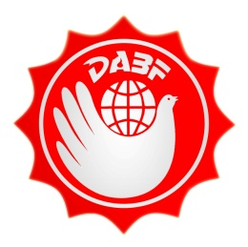

FEDERATION OF DENMARK ALEVI UNION

18 March 2015
EUROPEAN PARLIAMENT
BRUSSELS/BELGIUM

Federation of Denmark Alevi Union
‘Science is our Way, Love is our religion’

ESTABLISHMENT
The Alevi immigrants from the left wing movement in Turkey have moved to Denmark in the 1970s, similarly to Turkey, they have gone in to an organisational movement in Denmark and they took leading parts in forming the immigrant worker organisations. The strong basis was formed following the political movements and massacres in Turkey, which resulted in the acceleration of the Anotolian people in Denmark becoming more organised.
The first Alevi movement in Denmark took place with the financial support provided to the community committee standing against the Corum massacre.
In the 80s, Alevis took their place amongst Left wing, revolutionary groups or groups looking for equal rights and stood against the fascism in Turkey from Denmark, supported the people financially and morally.
At 1993, when the Sivas massacre took place, after return from summer holidays , Alevis formed the Arhus city HBV Cultural and Support Centre in 1994. Following this, Alevis took roles in the local government more to voice their demands rather than being in an immigrant status; on 11th September 1999 in Ringsted city Unity of Denmark Alevi Federation was founded with the contributon of 6 Centres; Kopenhag, Ringsted, Slagelse, Hedensted, Arhus and Randers.
At the same location on 25th May 2001, with hosting of DABF, the Unity of European Alevi Confederation has received its formal status and on 18th June 2002 at the Unity of Europe building, the formation of AABK was formally announced.

ACHIEVEMENTS
Unity of Denmark Alevi Federation from the day it was established to today, has a fixed basis and moved on by involving different groups in its events. It has supported the organisational structure, other friend federations and Unity of European Alevi Confederation as much as possible and has always supported the joint Alevi movement. At the times when there was attempts to describe Alevis, the investigations were made to see the way the government identifies the Alevis and attempts were made in order to have the Denmark government recognise Alevis formally. The two years work that started in 2005, resulted on 25th October 2007 Denmark formal recognising the Alevism “human right, science bound, religious of love” .
‘Unity of Denmark Alevi Federation’s’ achievements as a belief community:
- We have received the legal guarantees against any possible attacks to our belief, religious leaders and organisations.
- Our pirs have received the right to perform marriage ceremonies legally.
- Our leaders coming from outside Denmark will receive residential status.
- We have received right to have an “Alevi Cemetery”.
- We have received the right to receive belief taxes in Denmark.
- As a belief organisation we are exempt from building, additional wages, charity and income taxes.
- We have received the right to have a say in new laws and regulations regarding the belief organisations, and able to ask for being a part of the working commissions.
- We have been able to receive government grants towards our cultural, social and informative events.
- The inforamtion given at school about Alevis are according to the contents of the religious information the Federation provides.

In short Alevis have the same rights as Christians in Denmark.

ORGANISATIONAL
In the perception of the government, Unity of Denmark Alevi Federation is the representative for all Alevis in Denmark. For this reason, if there is ever a need to take action against an Alevi organisaiton in Denmark, the application is firstly made out federation in order to seek our opinion.
In 1998, the Alevi youth stating at the first Alevi youth camp,” Science is our route and love is our religion” is part of our Denmark Council. The Council as well as being organisational and plural, is part of the federation organisations. There are only two non-Christian organisations as members of the Council.
In 2013, Unity of Alevi Women, has been able to introduce itself to the public with their liasing with other organisations and federations that work against inequalities and equal right to live.
After being formally recognised, were able to meet the prime minster of the time Mr Ander’s Fogh Rasmussen and been able to voice Alevi demands.
With the increased interest in our federation, with our work for the prosperity of Denmark; is for our attempts of the recognisition of the dangers ahead. We are answering the demands we are receiving, we are supporting them in trying to stop the sharia groups emerging in Denmark.
Alevi identity and existence of its belief has mainly been achieved in Denmark and it has received the formal status. We have travelled a long way from the day of establishment, but the ones we have been able to implement in comparison to our the previleges we hold in this country are minimal.
Our demand: We hope that our motivation, political superiority and rights we have gained are achieved by our people in Turkey too and Alevis to achieve the level and position they deserve in Turkey.

OUR PRINCIPLES
1.” Science is our route and love is our religion”.
2. Our Kaaba, holy book and belief is the human.
3. We perceive all nations in the same level.
4. We do not discriminate between women and men.
5. We support the disadvantaged and stand against the oppressor.
6. We control ”our hand, tongue and body.”
7. All universe turns in semah; we always defend evalution.
8. We are members of the route; we make our promise and enter it, we stay on our route with guidence.
9. We know the friend’s conversation, know the knowledge from the school of mature person.
10. We respect all religions, but we will not allow them to rule us.
11. ”Our route is our way, and we turn every flower in to honey”.
12. Alevism is our belief, knwledge, fight and love..

Regards
Joint Chairperson, Cagdas Saglicak
Federation of Denmark Alevi Union

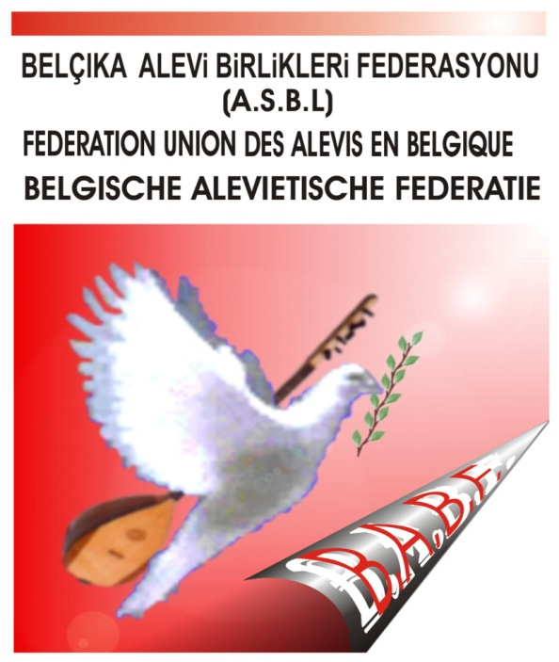

FEDERATION OF BELGIUM ALEVI UNION

18 March 2015
EUROPEAN PARLIAMENT
BRUSSELS/BELGIUM

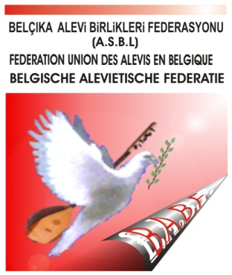 FEDERATION OF BELGIUM ALEVI UNION
Chaussée de Mons, 439
1070 Bruxelles
The Alevi citizens, estimated to be in numbers of millions have emmigrated from Turkey to various different countries in Europe in the 60’s for economical, social and political reasons. This mass group of people have started to live in a different cultural environment to their own, in order for survival has made adaptations and today has undertaken important roles. In an envrionment they have arrived as immigrants, naturally made additions to this environment with their own language, customs, art and cultural elements. Amongst the total number of immigrants in Belguim, it is estimated that about 50 thousand of those are Alevis.
In the recent years, especially with Alevism being in the frontline, the Alevi organisational belief soul has been renewed, many Alevi Cultural Centres have been formed in order to make additions to the life of citizen organisations.

The 3 main reasons for becoming organisational in Belgium;
Alevi citizens of Belgium have moved from status of guest workers and become real citizens and part of Belgium
To live and enable others to live in their belief and doctrine in Belgium. In order to avoid assimilation and to pass on their belief and religion to the future generations.

Alevis in Belgium united together in 2002 and formed the Unity of Belgium Alevi Federation in order to support the rights and struggle of Alevis in Turkey; to help the Alevis in Turkey avoid assimilation, to stop the government pressure and violence against Alevis in Turkey.

BABF‘s members:
BABF; is formed by the Alevi Cultural Centres in Belgium in the areas of Antwerpen, Bruksel, Charleroi, Limburg, La Louviere, Liége Verviers and Gand.

BABF’s foundation period:

The decision to form the Unity of Belgium Alevi Federation was taken in order to form a strong organisation like in the case of other European countries. Following the preparation work in 2002, the Unity of Belgium Alevi Federation was formally set up on 17th January 2003, with the constitution being published in the Belgium Official Gazette.

BABF’s aims:
BABF is a Secular and Democratic organisation. It has no links with any political organisation or party. It defends the right for everyone to live in equality. It fights to have the principle of peace and community unity. It does not make religion, language, colour, ethnicity discrimination. It respects laws universal principles, and the human righs and freedom. It carries out work in order to develop and protect the Alevi belief and cultural identity. Based on the mutual understanding pinciple, it promotes the unity of different ethnic groups and enables them to live together in peace and friendship. It defends these principles in every aspect of life.
-BABF’s Activities:
BABF has carried out its work according to its aims since being founded.
Joint work with other organisaitons, groups, Belgium government bodies, political parties and local and general government is undertaken in addition the the activies carried out with its member organisations. The main activities carried out are; the youth education and sports camps, education camps for Women, friendship days, Sport Tournaments, Social and Cultural activities
Our voice is also heard with the annual cultural festivals organised. The federation is supported by thousands of people attending the festival as well as the attendance from Turkish Consulate General, local and general government representatives and European Parliament representatives.
The Federation also receives financial and non-financial support from the General and local governments, the immigrant integration organisations, Ministry of Culture an Education towards the projects and activities undertaken.
The attention and trust placed upon our organisations is increasing every day with the positive and productive work carried out by our federation in Belgium, where appoximately 50 thousand Alevis reside.
Unity of Belgium Alevi Federation believe that these work that has social and Cultural aims, will enable us to establish the friendship between all groups, and make contributions to the democracy, human rights and global values. Therefore the federation will carry on with its activities by protecting the values gained by activities carried out in the past.
- Voice of Alevis Magazine;
The magazine that has been published in Europe since 1994 has been supported by ourselves and all member AKM’s, the membership and subscription has been promoted and the publishing has been supported.

- Foundation of Unity of European Alevi Confederation (AABK);
Unity of European Alevi Confederation has been founded in the European Parliament, Brussels in 2002. BABF members have supported its foundation, as it was formed in the same year as BABF, we have became members of the confederation immediately following our foundation.

Yol Tv;
In order for Alevis to set their own agenda and to be able to fight the current system, we have helped in formation of the Yol Tv. According to the decisions taken by AABK in line with the membership numbers in our AKM’s we are supporting the YOL Tv financially and morally.

- BABF’s Funeral Fund;
In order to share the bereavement of our community we have set up the BABF Funeral Fund in 2010.
Our funeral ceremonies are carried out according to our Alevi belief.

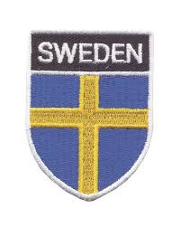
SWEDEN ALEVI FEDERATION

18 March 2015
EUROPEAN PARLIAMENT
BRUSSELS/BELGIUM

ESTABLISHMENT

Swedish alevi organisatThe first ion Sweden Alevi Cultural Centre was founded in Stocholm in 1995.
SWEDEN ALEVI FEDERATION
ALEVITISKA RIKSFÖRBNDET (ART)
It was founded on 2nd November 2008, by the unity of various Alevi Cultural Centres formed in different cities. The headoffice is in Stocholm.
MEMBER ALEVI CULTURAL CENTRES
- Stocholm Alevi Cultural Centre
- Uppsala Alevi Cultural Centre

- Dalarna Alevi Cultural Centre
- Göteborg Alevi Cultural Centre
- Malmö Alevi Cultural Centre
- Halmstad Alevi Cultural Centre

AABK – AEU
Sweden Alevi Federation is amongst the set up committee of Unity of European Alevi Confederation
ALEVI POPULATION
We estimate the Alevi population living in Sweden to be approximately 12,000.
The members of the Federation are in the region of 3,000.
ALEVISM AS A UNIQUE /INDIVIDUAL RELIGION IN SWEDEN
With the applications submitted by the federation Kammarkollegiet have accepted Alevism as a unique/ individual religion in December 2012, furthermore the federation has been accepted as the sole representative of Alevis in Sweden.
Alevis in Sweden will receive the equal rights to all other religions in the near future, we are awaiting for the final decision from the government.
ACTIVITY AREAS
- Belief
- Youth
- Women
- Culture
- Education
- Racism and discrimination
- Integration
EDUCATION AND ACTIVITIES
ALEVISM SEMINAR AT THE SWEDISH PARLIAMENT
Sweden Alevi Federation as part of the program for 2014, for the first time, with the support of Swedish MPs, have organised a seminar where, Alevism history, Alevis today and their problems and solutions to these problems were discussed;
AABK Chairman MrTurgut Oker and
Researcher- Writer Mr Turan Eser also attended this seminar.
POSITIVE SEPERATION
Sweden Alevi Federation and all the member Alevi centres have a 50% female places reserved..
The first female chairperson has also been from our federation.
It is run by the system of joint leadership, and it is compulsory to have one of these chairpersons to be female.
50th ANNIVERSARY OF IMMIGRATION FROM TURKEY AND 20TH ANNIVERSARY OF SWEDISH ALEVI ORGANISATION
Sweden Alevi Federation is part of the events organised for the year in order to mark the 50 years in Sweden by the contribution of the 14 Turkish origin organisations.
Evenst are being planned to mark the 20th anniversary of Swedish Alevi organisation.
ALEVISM HAS BEEN BROUGHT TO THESE DAYS BY THE MINSTRELS
In our belief our saz is the Koran (holy book) with strings, the minstrels’ writings are the chapters of this holly book.
For this reason Alevism has been brought to these days by the minstrels.
I would like to end this presentation with a poem about the immigration to Sweden.
SWEDEN HAS BEEN OUR HOME FOR 50 YEARS
We got on the way with our wooden suitcases
Sweden has been our home for 50 years
Powerty sent us to strange places,
Sweden has been our home for 50 years
-.-
We left from Sirkeci on the black train
With the sound of the siren breaking our hearts
They saw us of with ceremonies from our country
Sweden has been our home for 50 years
-.-
We did not know our way, our their language
We took every job that came in our way
Ten of us lived in a small
Sweden has been our home for 50 years
SWEDEN HAS BEEN OUR HOME FOR 50 YEARS
We wanted to retun, once we had enough money
However, we got used to life here
Eventually it has become our second home
Sweden has been our home for 50 years
-.-
We learnt the democracy here
We formed ourselves a small world
Became friends with Olof Palme
Sweden has been our home for 50 years
-.-
Cagan Ali says we belong here
We hurt from missing back home
We are from everywehere were humanity is from
Sweden has been our home for 50 years
Ali Cagan- Minstrel
2014-11-15 Stockholm

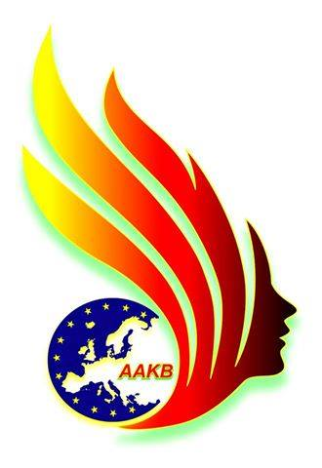

UNITY OF EUROPEAN ALEVI WOMEN

18 March 2015
EUROPEAN PARLIAMENT
BRUSSELS/BELGIUM

UNITY OF EUROPEAN ALEVI WOMEN

ESTABLISHMENT
Unity of European Alevi Women, starting from January 2012 had the preparation meetings in Sweden, Austria and Switzerland, and the first wider gathering took place in Germany-Cologne on 30th November and 1st-2nd December 2012.
Following a meeting held by the Constitution group, between 1st-3rd June 2012, the temporary management committee and distribution of responsibilities has taken place.
The head office is in Germany.
UNITY’S PRINCIPLES
- AABK, is and independent, democratic, special and legal social organisation.
- AAKB, sees itself as part both the European and Global women’s movement.
- AAKB, acts in accordance with the short term and long term strategic aims, actions and policies of the European Alevi Confederation.
- AAKB, respects women health, rights to make decision about their body, and theor sexual preferences.
UNITY’S PRINCIPLES
- AAKB, takes care of the environment we live in by taking the Alevis’s vision of universe, nature and human triangle’s unity.
- AAKB, takes care of the Alevi philosophy of male-female equality and depth of tolerance.
- AAKB, accepts the Universal Declaration of Human Rights and believes in women problem being one of the human right issues.
UNITY’S AIMS
- AAKB, works in order to improve the positions of Alevi women in the organisations they are in and tries to strengthen their place in the decision making mechanism, in order to make them more active, gender equality in all parts of the society and ensure women make equal amount of contributions.
AAKB, works in order to protect the Alevi Culture, to ensure passing on the Alevi’s culture of tolerance to the younger generations in line with the developing and changing world. Fights against the backward customs, male dominant community, unwanted forced child marriages.
- AAKB, supports Alevi women’s education and helps them gain their economic freedom despite the family and community inequality in education.
- AAKB, stands up against the physical, physiological and sexual violence against all women and Alevi women. Shows zero tolerance to every type of inequality and helps women fight against social, economic and cultural discrimination.
AAKB, inline with its constitution, works in unity with other democratic women organisations, despite their ethnic, religious, social and cultural differences.

MEMBER ALEVI WOMEN ORGANISATIONS
- Unity of German Alevi Women
- Unity of France Alevi Women
- Unity of Denmark Alevi Women
- Unity of Austria Alevi Women
- Unity of Belgium Alevi Women
- Unity of Sweden Alevi Women
- Unity of Norway Alevi Women
- Unity of Britain Alevi Women
- Unity of Holland Alevi Women
- Unity of Switzerland Alevi Women

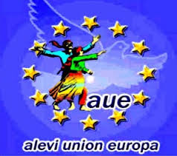 Unity of European Alevi Women, is part of the Unity of European Alevi Confederation.

The opening reception took place in Berlin on
1st of March 2014.

SKYPE MEETINGS
The management committee members and others members reside in various different countries in Europe.
For this reason, in addition to our management committee meetings, we are in contact with each other through the weekly Skype conferences.
ALEVI PIR ANA’S ARE SITTING ON POST AND RULING CEM CEREMONIES
On 15th February 2015, in Germany’s city of Wupertal, for the first time Alevi Pir Anas have carried out the Hizir Cem with moral support from AAKB.
8th MARCH
INTERNATIONAL WOMENS DAY
At 8th March, International Women’s Day, in addition to the local
events, AAKB has organised central events in Austria and Switzerland.

ALEVI WOMEN FEDERATION EVENTS
The unity of AAKB, with all Alevi Women Federations and Women Commissions in all of the countries carries out various and important events, in addition to this they take active roles in all of the international women platform’s events.
VIOLENCE AGAINST WOMEN
We are going to have a meeting titled ‘Violence Against Women’ in Britain on 25th November 2015.
SUPPORT FROM WOMAN TO WOMAN
Our campaign ‘Support From Woman to Woman’ launched on 8th March 2015 and ending on 8th March 2016.

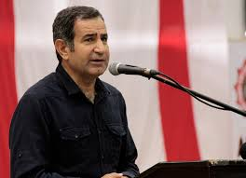
Dertli Divani, Minstrel

Alevism Conference: in the trap of Politic islam,
The presentation for the Alevi problems and demands in Turkey
Wednesday18th March 2015,
European Parliament, Brussels, Belgium
Dear guests and cans; greetings...
According to the Alevi – Bektasi belief, since the beginning of life to this day, all religions ever existed, beliefs and ideas have taken influence from each other and are linked like circles of a chain.
Alevi-Bektasi belief does not discriminate based on belief , race, language, religion, colour, gender. All creatures are Hak’s, God’s reflection and are the visible form. Those who endanger humanity and environment eliminate themselves from Hak and God.
Alevi-Bektasi belief, has placed love for human/humanism in the centre of its belief. For this reason, Hunkar Hace Bektas Veli said “We look at the 72 different nations in the same way”.
The Cappadocia area where Haci Bektasi Veli lived is one of the central areas for Christians. Haci Bektas Veli and his followers have never tried to influence anyone with their own belief and ideas, but only stated their own belief and ideas.
According to our belief, the government interruption to ones belief or to force one group to benefit another religious group is not acceptable.
Unfortunately, the interruption and pressure to our belief is Turkey’s reality. The root of the problems Alevis have in Turkey lies in this interruption and pressures. These interruptions and pressures, are the customs of the Ottomon culture they are under the influence of. The Republic governments that took over these customs have carried on with massaccare and pressure policies..
Today, the AKP governments, have increased the weight of the Islamic Politics with the policies they have called “the New Ottomism”.
The way the pressures and assimilation policies are impleted might change but the essense are still the same. The government influenced by this understanding sees all ethnic minorities with different religion, origin, belief and ethnicity as minorities to be destroyed. Assimilation politics are implemented in order to ignore all other communities and turn them into “Sunni Muslim Turks”.
These pressure and assimilation policies are mainly forced upon Kurds, Armenians, Orthodox and other Christians, Assyrians, Ezidis, Jewish people. Alevi-Bektasi-Kizilbas community are one of the other communities that have seen the implementation of these policies on them on a large scale.
The problem of restructuring the government and new constitution is a problem facing Turkey. The main principles of the constitution should be secularism and democracy. The abolishment of the Ministry of Religious Affairs is imperative for the achievement of secularism.
Alevi-Bektasi-Kizilbas belief from the social point of view is living in secular and democratic life style. Alevis are secular and democratic group of people. Unfortunately, Turkish Republic has never been able to be Secular and Democratic.
The main duty of the government is to hold the principle of impartiality and to be in an equal distance to all beliefs, to form the democratic basis where everyone respects each other and where freedom of speech exist.
It is not acceptable for the governments or local governments to directly or indirectly providing financial support to religious groups.
Every group must be able to raise the financial support within themselves for their own existence. The governments must not have members working for religious groups.
In connection to this, we are against the wage allocation to dedes (our religious leaders) by the Ministry of Religious affairs.
The government must not be involved in the religious studies at schools too. Religious education, must be turned into a sole responsibility of the religious groups themselves.
The 4+4+4 education system being implemented is attempts of the AKP government to change all different groups and turn them in to groups like themselves and their assimilation policy. The children’s brains are formatted according to the Political Islamic and Sunni belief.
Alevi-Bektasi-Kizilbas belief has been accepted as an independent religion in Europe. Alevism lessons are taught by Alevi teachers at schools, unfortunately this is the opposite in Turkey.
However, a group must be accepted in the way they express themselves. Although this is a key right, we have not received this right yet.
We believe the successes the European Alevis have gained will be gained in Turkey eventually.
For this reason, we must carry on fighting for the first step of the implementation of the decisions taken by the European Court of Human Rights regarding the issue of the compulsory religion lessons as soon as possible.
I greet all of you with love and respect. Ask ile....

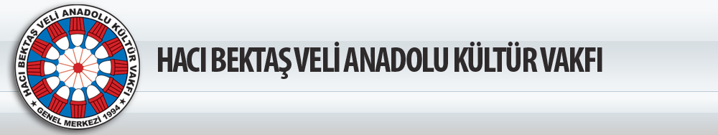

Ercan Gecmez
HACI BEKTAS VELI ANATOLIA CULTURE CHARITY

Dear members of the parliament, ladies and gentleman
I would like to thank you all for giving me this opportunity to make this presentation today.
I am sure you have listened on this stand, the endless and increasing problems of Alevis in Turkey as the largest ethnic minority group in Turkey. We are aware of the different Alevi representatives at different times, presenting the Alevi problems to the parliament. therefore, if we compare two presentations from past, at different times, we can clearly see that the problems discussed are very similar, Turkish Republic governments rather that solving the problems, are creating more problems, instead of dealing with the Alevi problems they have tried to shape these problems in the way their interests are benefitted, or ignoring these problems, when this is not enough turning them into marginal groups and making them targets of various different groups. We can say that the government has no intention of accepting our Cemevis as legally places of worhip for Alevis. Although European Court of Human Rights have made decisions to support Cemevi status, the prime minister Davutoglu has made statements such as “these are not issues to effect our work program” and shown their ignorance, and know by everyone to have taken their traditional political approach. In the same way, the existence and non existence matter for Alevis, the matter of compulsory religion lessons also remains to be a problem. European Court of Human Rights have made suggestions to restructure the compulsory religion education system and suggested that the exemption from this lesson to be allowed where necessary, the government does not seem to be willing to listen these suggestions and these is no light of hope for the short or mid term. The problems that the Alevis face and are incresing by the policies of the current government, at the same time is countinuing with their ignorance of the attacks, massacres, massacre attempts, laughs at Alevi pain, for example by indicating an extreme nationalist political party as target in order not to face their history but do everything to divert the historical mistakes made in Dersim. The main opposition party CHP has been chosen as a target for this massacre, closed their ears to all applications made in order change the name of the city from Tunceli to its real name of Dersim. Alevis are shown as targets for every community and political matter the government face and the attempts to isolate the Sunnis and Alevis are also very well known matter that does not even need to be stated here. Therefore, the current and past governments have always perceived Alevis as a community to keep isolated in order to use them in their seperation policies and have not been seen as a groups of people who need genuine solutions to their problems.
Although, I am here today as the Chairman of the Haci Bektasi Veli Anatolia Culture Foundation which is one of the largest Alevi organisations whith 43 centres, I want to present here not a a chairman but as an Alevi citizen, a citizen of Turkish Republic. Because today, the threat posed by the AKP government who has been in power for the past 10 years is not just a threat for Alevis and connected to their demands. Today, all of Turkey is under threat. This threat is not just the problem of Alevis, but problem of all groups who are not members of the dominant Sunni group. I want to draw your attention to a current event. At Sarikamis 100 years ago, the Ottoman Empire have lost 90 thousand soldiers in Sarikamis. In the past 10 years the commemoration services are carried out by the nationalist groups for these soldiers. This year to mark the 100th anniversary, the Turlish Parliament leader, Home office minister, Youth and Sports minister have joined these commemorations. The Home office minister has made the following statement to the press “they have become casulties in order to protect their religion and give lesson to the people in these soils” clearly, this statement alone shown their discriminative attitute. The Armanians together with Alevis who fought in the Ottoman army have been totally ignored here. Their discriminative attitute goes back to the dephs of the history and shows that they deny your existence from back then if you are not Sunni. This ignorance policy comes accross us in every level of the political life. For example, the AKP’s previous Culture minister Ertugrul Gunay have made a statement that has never been forgotten, he said that while AKP have been in power not on Alevi judge’s job application has been accepted. This discriminative language and the politics behind it, not just discrimnative towards the Alevis, Alevis are the largest group as the victims of this discrimination, they use the Alevi community to cover the fact that AKP being the source of the threat.
If you are not Turk, Sunni, male, adult and heterosexual in Turkey today, you are under threat! Alevis not being accepted to public sector jobs to one side, for example if you are a female you can face being murdered based on custom, or honour killing, the murderers being subject to crime discounts, face male violence, possibility of being raped, and not allowed to work in the public sector.
The job of teaching, mainly undertaken by women can be seen as s good example here. When we look at the numbers, the school management numbers in Turley are 62,333, only 6,701 of these are women, 55,632 are men; out of the 81 city education managers, only one is woman, 80 of them are men, out of 718 town education managers only 3 of them are women, 715 are men; out of 255 deputy managers city education departments only 8 are women, 247 are men. In the state schools the percentage of women are 11% , the men are 89% . We can come accross a similar picture in the Ministry of Religious Affairs. In total 128,847 people work for this organisation, at its headoffice 1040 people work, only 67 of these are women, 973 are men. The rural organisation employs 103,560, 87,104 these are men and only 16,456 are women. In total women are represented by 15% and men are 85%.
Ministry of Religious Affairs also tries to make the women more passive and locked at home by the publication it makes every now and then, supposedly based on Islamic religious references. For example; the women not being allowed to travel without their husbands, also not allowed to be alone with even their sister in laws, have their hair cut or wear a wig to be forbidden.
If all of these are not enough, women are excluded from the community life, starting with the basic education rights and attempts are made to exclude the girls from the basic education system. For example; The Education Council held between 2nd-6th December 2014, the Egitim-bir –Sen who is the union that is the government’s gunman has put in the agenda of the meeting the suggestion of mixed schools being abolished and in addition to this the religion education to be provided at pre school ages. These suggestions have been accepted at the Council and the Education Minister Nabi Avci has said, he is warm to the idea of mixed schools being abolished and that there is no need to make additions to the current school numbers.

If you are a woman in Turkey you must be prepared to live under male violence and being laughed at. For example; according to the AKP’s Family and Social Policies Minister, in 2014 there were 170 women murdered in Turkey, compared to 330 in Germany. However independent civilian groups have stated these numbers to be 636. If we listen to the minister the women in Turkey have a safer life compared to Germany!
If you are child in Turkey, you are under threat from childhood to the end of your university life. You have to attend the compulsory religion lessons from year 1 and your delicate brain that tries to understand the world is darkened by the shadow of the government’s religion. The education council I have mentioned earlier, has also accepted the compulsory religion education to satrt from year 1. According to this, the primary years 1,2,3, had the compulsory religion lessons added to their curriculum. Unfortunately, to be able to be exempt from these lessons despite the Turkish Constitution and the global legal principles are only possible by declaring your identity and this right is only given to the non-muslim ethnis minorities that received homogeneous identity with the Lausanne Peace Treaty. You have no right to oppose the compulsory religion lessons if you are Alevi or even Sunni. As if this is not enough the pre school education to be the centre of “values education” and the religious lessons have entered to the nurseries. This Council meeting has started to receive its results already, The city of Osmaniye, Kadirli Town, the education minister has ordered all nurseries to start lessons with the religious pray and have pray learning days. According to this, a weekly pray timetable will be drawn, prays and “Allahuekber” is to be taught in movements; the chils will clap as they turn around and say the pray, and when saying “Allahuekber” to be motivated by saying lets see who can say it the loudest.
Futhermore, most alarminly after the 4 years primary education, the children to be allowed to have not one year but 2 years out of school to have eduction to enter religious schools and to be able to enter the exams en if these 2 years are taken out, have been accepted. The same council meeting has brought the religion to front and the safety lessons such as traffic safety, human rights, citizenship and democracy lessons have been taken out their programme completely. As if this was not enough; At the Anotolia Tourism and Hospitality high school students who were being sent to work experinece at hotels from year 10, have now been stopped from receiving work experience at hotels departments serving or preparing alcohol .
The imam hatip high schools that have the main aim of raising religious people for the sunni community have become the Turkish Education System’s backbone. Their numbers and teachers are increasing and students against their will are being placed in these schools. Sunnism is becoming the main focus at the exams when entering the secondary schools. All other schools have been taking these as their examples. For example; the Ottoman lesson at these school have been spreaded to all other schools based on “we are not able to read the gravestones of our ancestors, our children should be able to read them” and the threats directly coming from the President Erdogan by his statement of “you will learn Ottoman lessons even if you do not want to”. If the same president looked at the Ministry of Religious Affairs that have strengthened will see their excuses are meaningless. Because, Ministry of Religious Affairs have declared in the past that writing on the gravestone not being acceptable and tries to abolish it. According to this, when asked “is writing name, surname, date of birth, date of death and sometimes words about this world being temporary... etc acceptable by religion?”, the Ministry of Religious Affairs have said “it is not accepted, religiously” also took it further by saying “it is a sin to write on the gravestone”.
Again a short time ago Erdogan declared that the real aim here is not teaching Ottoman language but to destroy Turkish. The lessons such as Philosophy, Sociology, Physhology , the evaluation theory have been abolished, only 2 years ago attacking those who said science cannot be carried out with Turkish and declaring them as racist, today is claiming Philosophy cannot be carried out with Turkish.
The students in Turkey, cannot save themselves even at university; from the education system poisoned by the Sunni Muslim pressures. Because today Ministry of Religious Affairs has a project of every university to have a mosque and every campus to have a religion room.
If you are not heterosexual in Turkey, your life is in danger. A Trans sexual Eylul Cansin committed suicide by throwing herself from the Bogazici Bridge recently. Her funeral took place at a cemevi. Everyone heard about her being a Trans sexual from her letter she left behind. The violence, pressure, torture and murders the non heterosexuals face in Turkey is not even being recorded. The AKP government’s forced Sunni Muslim life upon everyone, excludes the non hererosexual individuals even from main Sunni demands. For example; Eskisehir F Type Prison LGBTI prisoners, have steted even when they want to attend the Koran Lessons, they have been excluded from receiving this right becaise of their sexual identity. These prisoners have stated “We are Muslim, we are not allowed to go to Koran lessons. They are acting as if we have no god”; it is as if you are not heterosexual, you cannot be muslim either.
In Turkey, if you are not a Turk, a Sunni and a male, you are under threat. If we look at the section of the Expression of Hatred in Media report, recently published by the Hrant Dink Foundation, we see that in the period May-august 2014 that on a local level, the leading provinces for expression of hatred are provinces considered as the forts of the AKP; namely media in the provinces of Konya and Kayseri. On a national level, the ‘Yeni Akit’ newspaper, the semi-official publication of the government, takes the lead. This is followed by the other publications, Milli Gazete (National News) and Milat News, both of which have religious identities. Jews and Armenians are the main target of the expression of hatred; and after these groups which homogenise all non-Muslims are of course the Kurds and Alevis. It is such that, while the Turkish government plays host to Syrian refugees on one hand, on the other it doesn’t move a muscle to stop the hatred being directed at them. Syrian refugees are next, after Alevis, as the target of the expression of hatred. This is not at all surprising. In order to show how the Department of Religious Affairs both poses a threat to the whole of society, and how it propagates animosity towards non-Muslims, we can simply look at one of their own documents; In the Department of Religious Affairs’ 2012-2016 Strategic Plan, under the heading of Threats, the definition given is “Activities which aim to break down religious and moral values, activities which aim to subvert the essence of Islam and its effect on non-Muslim people which would have a negative effect on our unity, attempts to interfere with the totality of Muslims through the introduction of non-Islamic beliefs, thoughts and orientations”. In the religious dictionary on the institutional website for the Department of Religious Affairs, non-Muslim is defined as “identifying a person who is not Muslim, blasphemous in religious terms, is a disbeliever and double-dealer” and in giving this definition they openly widen the target area. The Turkish government, with a few nationalist groups by its side, in view of its own political interests, accuses non-Muslim communities as participating in missionary activities thus making them a target. Yet, in the same way that Alevi places of worship are not counted as a place of worship in this country the situation for places of worship of other religious groups is no brighter than that of Alevis. The low figures confirm that to open up a place of worship means to be ready to face hatred and be prepared to cope with the thousands of difficulties that will be faced. An example is that in the whole of the country there are 321 churches of which 52 are Protestant, 53 other which also include Orthodox, Catholic, Syrian Orthodox and Chaldean churches. There are 36 synagogues, 7 masonic halls (mahfil), and only 9 places of worship for Jehovah’s Witnesses.

The problems faced by Alevis need now to be viewed collectively with those who face the threats created by the warlords who hold the power in their hands. Only then can the true measures of the threats faced by Alevis, one of the largest minority belief groups, be truly understood. Otherwise, you probably know better than I do that, despite how much the government faces Europe and generates lie upon lie, as an example, Alevism is not part of the compulsory religious education nor is it part of any other educational programme. Because we are explaining or teaching Alevism, the official syllabus cuts back, hides and misreports all our attributes which are outside of their Sunni understanding. Our children are now indexed to a political viewpoint which is indexed to the interests of the elite, they are being recruited to political Sunnism. Alevism is going to be, from time to time, mobilised in various ways, for this political elite and it carries no other meaning than that of a religious system which will reap an income from it. While, its religious characteristics continue to be censored, as always, in Sunni mentality circles, by being presented as a folkloric diversity.
There is not a single academic institution working on Alevism, which can be taken seriously. There are five separate research centres in five different universities in this field. However, these research facilities, which have the phrase Alevi in their name, are almost completely in the control of Sunni theologians. Those that are not in the hands of Sunni theologians try to use nationalist-Turkish- government based ideologies to rebuild Alevism and in doing so take away its history. These centres that are wholey in the control of Sunnis and moves according to their instructions, have the main mission of according to their geographical position selected carefully when setting up is to destroy the unique Alevism and its treasurers and build one that serves today’s powers in charge.
You do not feel the need to speak about the deaths, massacres and lynch attempts encountered and experienced by Alevis, who have from the past to present been the object of hatred for a country. I do not have to say to you that producing hatred is a known value of the AKP government, it tries to spread the hatred by using Alevis, they are forcing our country to enter a dangerous division. Furthermore, they are also attacking Alevis living outside Turkey, they are trying to damage their reputation by presenting them as terrorist organisations, especially in Germany, these attacks are increasing. It is clearly observed that, they want to damage the reputation of the Alevi organisations in Europe, lead by Germany, as they perceive them to be the source of problems they face with Alevis. Despite everything, thanks to our history, our memories, our own organisation, our friends, be they Alevi, Muslim, Turkish or heterosexual we are still standing and will continue to stand. It may seem weird to you, but it is at this point that I wish to speak about Cemevis.
Today, in the whole country, the total number of Cemevis, which hold a position of a place of worship and are the topic of international legislation, is 937 in 81 provinces. In contrast, the number of mosques in the country are 83, 693. While there are mosques in every province of Turkey, there are 31 provinces with no Cemevis. For example, in Istanbul where there are 3113 mosques, there are only 64 Cemevis. While tens of thousands of mosques are funded through public funds, the Cemevis of Alevis have to struggle to exist in the face of great difficulties and the governments constantly developed new forms of oppression. No matter what happens, Cemevis will continue to and must continue to exist. I would like to clearly indicate here that Cemevis are not only the place of worship of Alevis. For the AKP government’s hatred towards Cemevis is not just a case of a different place of worship within Islam. Today the use of the name Cemevi is actually a complex. In most Cemevis in addition to it being a place of worship, it is also used a place for funeral services and so has a morgue and a place to wash the dead, and in addition to this a soup kitchen, conference and theatre halls and even small cinema halls, rooms for lessons to take place and even guest quarters. The AKP mentality is against this complex as a whole. This is because Cemevis take on an important role or service that the tens of thousands of mosques do not provide citizens with. Alevis are not interested in whether a body brought for its funeral is heterosexual, a child, a woman, a Muslim, a soldier, a terrorist or whatever else you can think of. The important things is only that a service is being requested. It is because of this that a transsexual that has committed suicide, someone killed in a traffic accident, someone killed by a stray bullet in the mountains, or executed by police in the city, a prostitute, a child will all get the same level of service in a Cemevi! It has never been the case that someone has been sent away from the doors of a Cemevi for this reason or that! Funerals not allowed into a mosque due to being a non-believer, an alcoholic, homosexual or a terrorist are revered in our Cemevis! Our Berkin Elvan took his final journey from a Cemevi, as with Sakine Cansiz and Eylul Cansin! This is not enough: our Cemevis are a hall for those who want to speak but have no meeting hall in which to do so, a classroom for voluntary teachers wanting to teach poor children, a soup kitchen from which those who came in hungry leave with a full stomach! It is a door that the damned can always come to with ease of conscience. This is not enough: Our doors are fully open to any Catholic who cannot find a place to worship in their city, any Protestant who has been no roof over their head, any Assyrian, any Armenian, and any Orthodox who needs a room in which to pray! What I am saying is that Cemevis are not just the place of worship of Alevis but also that of Armenians, Jews, Catholics, Orthodox, Anglicans; Cemevis belong to the oppressed, the poor, the unemployed, socialists, communists, Kurds, Ezidis and Arabians. The great hatred towards Cemevis is partially because of this reason too. It is because of this that everything to one side, I want to talk about Cemevis. I want, however, to state that we, the Alevis of this country, with various identities no longer wish to come together for funerals. We want to be one with our living not with our dead.
Those of you who think that this is a simple, plain, pure, humane and at the same time ordinary wish need once again to remember the words of the Republic of Turkey’s ex-prime minister and now new president Recep Tayyip Erdogan and those of prime minister Davutoglu who walks in his footsteps. For example, Tayyip Erdogan berates a female journalist saying that “Some despicable woman speaks in the media and excuse me, begins to insult Muslims. There no answer from him. Look at this state. Who do you think you are? Know your place.” The same Tayyip Erdogan goes on television and tries to force the leader of the opposition, Kılıçdaroğlu, to announce his Alevi roots and identity. “Are you not an Alevi?” he calls, Kılıçdaroğlu does not openly say he is Alevi. We know that for the president, whether you are Alevi or Sunni is important in death also. On May 11th 2013, when we lost citizens in the Reyhanli attacks he emphasised their Sunni identity, “53 Sunni citizens were martyred today” he said. However, the president who so wholeheartedly attacks the identities of others does not neglect to belittle the Armenian community, when it is his turn, by saying that “There have been those who have said I am Georgian, and pardon me, those who have in an even more hideous way called me Armenian”.
Turkey has a president who looks at the world in the eye and says “ I am ignoring the decisions of the Constitutional Courts, European Court of Human Rights will not be ruling us, if you have the powers you can try and demolish my castle, I am going to clean the legal system, if the HSYK elections do not turn out the way we want, we will not accept the results”. This president hates and cannot stand anyone but himself, and tries to use the Sunni majority’s sensitivities. He still tries to provoke the Sunni population by saying “they have entered the Dolmabahce Mosque wit their shoes on and beer bottles in hand, during the Gezi events.” This is not enough for him; he divides the population in half by saying, “you cannot bring women and men to equal levels, this is against our instincts; feminists will not accept motherhood”. Also says “the small busineses are soldiers, heros, police and judges when required” and ignores the whole organisational structures, political and legal organisations and tries to hand the punishing and protection duty to the community. Unfortunetly his successor Davutoglu is following the lead of Erdogan, who says he will not take orders from anybody but God. The Presidents’s heavy words against women are also repeated by the Prime Minister in an more academic language, he also like the president does not value human life and the organisational structure based on the political and legal system. Following the murdering of two security force members in Bingol on 9th October 2014, people were murdered without being sentenced or tried. Both the Prime Minister and the President have said “Violence will receive violence in many times more (...) the perpetrator terrorists will receive their punishment in couple of hours. Our security forces have chased these traitors and killed them”, it is not clear whether these “traitors”they have killed are responsible for the attack at all, the file remains to be unknown perpetrator.
In this kind of Turkey, it is imperitive for Alevis to unite with other ethnic minorities and be together not just at death but life. This is a matter of life or death for Alevis. In this existence environment, the small Kobane’s resistance in a big way is giving us hope. We hoped to feel the same for the Turkey’s so called negotiation process. However Turkish government is using the negotiation process to divide the population, and eliminate certain people from the negotiations to have a result they desire. The AKP being forced to negotiate is as a result of the Kurdish movements success. But AKP, declares the parties they have to negotiate with as terrorists, silence the voices speaking the Kurdish problem at the parliament, and tries to show the negotaion process as a matter between their own intelligence services and Abdullah Ocalan who is detained by them. One one side they appear to be negotiation, on the other side the Roboski matter has not been resolved and more Kurdish youth are being murdered in cities! As if this is not enough, AKP government is trying to bring the Kurdish political movement agains the radical Islamic political movement and aims for them to attack each other. You can see that the AKP is using the religion here as well.
From this point of view, in the same way as the intelligence service have turned in to a war tool, Ministry Religious Affairs has also turned into main ideological tool of these war lords. For this reason, since the AKP have been in power Ministry Religious Affairs budget has multiplied every year. When it was 771 million in 2003, one year later it was 1 billion, when 2010 came, it was 2.7 billion. In 2012, the budget was 3.9 billion, in 2015 it has increased to 5.7 billion. This equal to 2 million 470 thousand Dollar or 2 million 35 thousand Euros. The real increase in the budget of Ministry Religious Affairs has occurred in the AKP government’s term. AKP ignores the demands of Alevis to have the Ministry Religious Affairs abolished, they bring it from the mosques to our homes, bedrooms, childre’s playrooms. The request to have the Ministry Religious Affairs abolished is not just a religios demand; this is clearly a political demand. Because abolishing Ministry Religious Affairs does not just mean the support for Sunnism to stop, it also means the most important policy of discrimination, inequality, hatred, dividing policies followed by AKP will also be abolished. For this reason AKP will never put his on their agenda and never will. Ministry Religious Affairs is the government; same as the TRT (State Tv). We must sadly accept that when the issue is abolishing Ministry Religious Affairs, it is only perceived as a religious matter and all other matters connected to the Ministry Religious Affairs are ignored and Alevis are isolated in this matter.
Honourable members of the parliament,
I have tried to explain the picture of today’s Turkey as short as possible. I hope, I have succeded. But, I want to especially underline the following; We Alevis do not want anyone to do anything for us. We have no demands from yourselves. I am not here to voice some demands. I am here only to say: as Europe from north to south, east to west has become home for Alevis, even if one single Alevi remains in Turkey, everyone on the side of equality, brotherhood, and friendship has a home in the place where only one Alevi remains! Today we are fighting for that house not to be alone. Therefore, nobody should do anything for Alevis, they should do something to keep the big house of equality and friendship!
I thank you for your patience and give you all my respects.

The fundamentalist terrorist groups that are global threat and Alevism
Summary
The fundamentalist religious terrorist groups that have increased their influence and became more of a threat since the “Green Generation Project” and communism fight strategies implemented during the Cold War period. These terrorist groups have evolved and changed from just being supported by their sympathizers and become more of groups supported by the Arab world financially and gained a paramilitary srtucture. Once they have gained these powers, in order to change the demograhphic structure of the Middle East , they have chosen mainly the Alevis, Ezidis, Syrian Orthodox and Christians as their targets.
The Terrorist groups that have been responsible for the many massacres in the area in the last four years have also became a threat to Europe. Today, we can see that relying solely on the intelligence information is not enough to fight these groups.
European Union, with its no border structure is fragile against these threats. European Union and all other global organisations must find ways to tackle these groups that are able to move from border to border, hide in every country they want and carry out attacks as they are pleased. The most important and immenient solutions are better management of borders, the liason of the citizen organisations, the crime committed in the digital environment to be punished and redefining the Islam in Europe.

Fuat Ates
YOL TV

ALEVI UNION EUROPE

18 March 2015
EUROPEAN PARLIAMENT
BRUSSELS/BELGIUM

ALEVI UNION EUROPE

18 March 2015
EUROPEAN PARLIAMENT
BRUSSELS/BELGIUM

